http://www.ableword.net/:
AbleWord Word Processor and PDF Editor v3.0 (ableword.net)
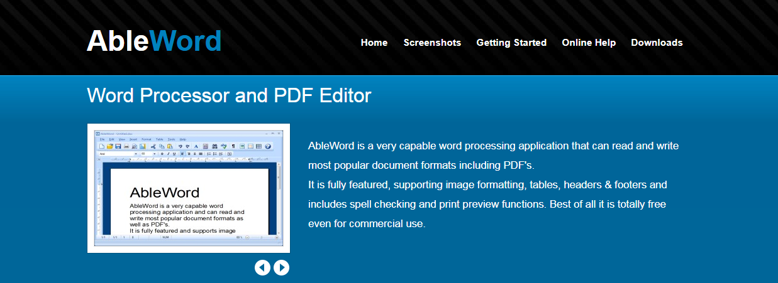
Contents
Edit PDF files as simply as Word® documents 4
AbleWord can read and write the following file types: 4
Download AbleWord 4
System Requirements 4
Latest Release 4
Download Here 4
How to uninstall 5
Download Starting... 5
How to Convert PDF to Word® 5
First open your PDF 5
Now save as Word® 5
Latest News 6
Help 7
Getting Started 7
Install 7
Opening Documents 7
Save as PDF 7
Main Toolbar Buttons 8
 New File 8
Loading and Saving Documents: 8
 Open File 8
 Save File 9
Printing: 9
 Print 9
 Print Preview 10
 Page Setup 10
 Cut 10
 Copy 10
 Paste 10
 Undo 10
 Redo 11
 Font Properties 11
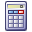 Document information 12
 Find 12
 Spelling 12
 Show/Hide Formatting Characters 12
Working with Images: 13
 Insert Image 13
Using Text Frames: 13
 Insert Text Frame 13
Using Tables: 14
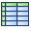 Insert Table 14
Font Formatting Toolbar 15
Bullets 15
Numbering 16
Tab Stops 16
Using AbleWord as a PDF Editor 17
Editing PDFs 17
Notes 19
Page Setup 20
Margins and Paper 20
Headers and Footers 21
Columns 22
Borders 23

Edit PDF files as simply as Word® documents
There are a few free Word Processing packages available for Windows but none come close to the features offered by AbleWord. It is highly compatible with popular document formats including .DOC & .DOCX but Ableword can also open and save as a PDF which makes it a very useful tool to have.

AbleWord can read and write the following file types:
- Microsoft Word® (doc, docx)
- Adobe® PDF (pdf)
- Rich Text (rtf)
- Plain Text (txt)
- HTML (html, htm)
AbleWord very simple to install and use, it is commonly used as a PDF Editor and also for converting PDF to Word® but of course it is also a splendid Word processor and supports most of Microsoft Word® features.
For more information see our getting started guide or online help.

Download AbleWord
The Installer will guide you through the install process and give you the option to create a shortcut on your Desktop as well as in Programs. Optionally you can create file associations so when you double click a Word® document it will open with Ableword automatically.

System Requirements
Operating System | Minimum Specification
Windows XP SP2  Windows Vista  Windows 7  Windows 8 and 8.1  Windows 10 | 1 GB Memory (RAM)  20 MB Free Disk Space  SVGA Resolution Display  .Net Framework 2.0 or higher
The .Net Framework which is required by AbleWord is inclided with WIndows Vista and Windows 7. If needed then Windows 8 and 10 will prompt you and automatically install for you.

Latest Release
March 9th 2015 Version 3.0

Download Here

How to uninstall
AbleWord includes an uninstaller if you wish to remove the software at a later date. This can be accessed from Control Panel - "Add Remove Software" or "Programs and Featues" on later operating systems.

Download Starting...
Your download should start automatically, if you have any problems then Click Here to retry.
After running the installer it will guide you through the install process.
AbleWord is constantly being developed so please check back for updates.

How to Convert PDF to Word®
Because AbleWord can read and write both Word® and PDF documents it is easy to convert between them -Word® to PDF or PDF to Word® in a flash.

First open your PDF
Press the 'Open' button on the toolbar as shown below.
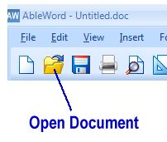
You can now browse your filesystem and open a PDF document.
When a PDF is opened in AbleWord it is automatically converted to a Word® document while loading, this process can take a couple of seconds per PDF page so if you have a large PDF then please be patient as it is converted.

Now save as Word®
To save the document simply press the Floppy Disk button to the right of the Open button and save with your desired file type (in this case PDF) as shown below.
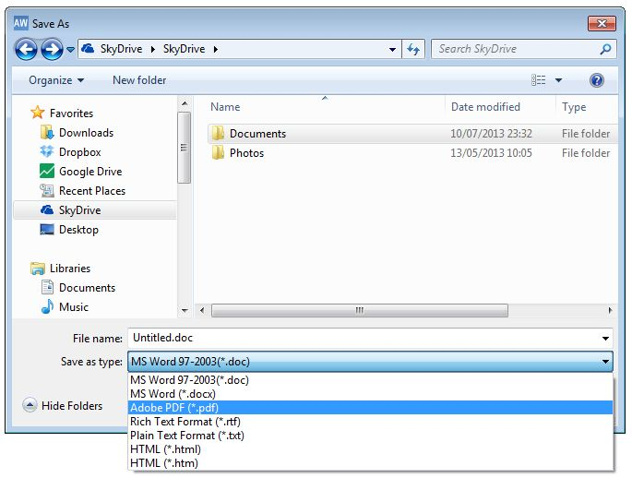
This is a very basic overview on how to convert PDF to Word® (.doc and .docx)
for more information on AbleWord please see our online help

Latest News
MARCH, 9TH 2015
v3.0 released. Faster PDF loading. Ability to import PDF Text only.

OCTOBER 10th 2013
v2.1 released. Added "check for updates" function and minor bug fixes

AUGUST 12th 2013
v2.0 released. Now includes PDF read/write ability and spell checking.

APRIL 7th 2013
v1.6 released. HTML import/export, fixes to Docx table formatting.

Help
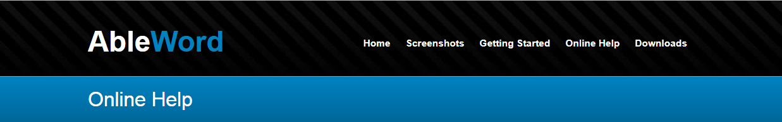

Getting Started

Install
First you will need to download and install AbleWord on your PC. AbleWord is compatible with Windows XP, Vista, 7, 8 and 10. Visit our Download Page to get your copy.
The Installer will guide you through the install process and give you the option to create a shortcut on your Desktop as well as in Programs. Optionally you can create file associations so when you double click a Word® document it will open with Ableword automatically.

Opening Documents
Now you have installed it is time to try it out!
Press the 'Open' button on the toolbar as shown below.
You can now browse your documents and open a Word® or PDF document. You can change the text, perform spell checking, insert images or tables.

Save as PDF
Word® files can be saved as a PDF or vice versa which is a very powerful feature.
To save the document simply press the Floppy Disk button to the right of the Open button and save with your desired file type as shown below.

Main Toolbar Buttons
Description of functionality of buttons on main toolbar

New File
Click on this to create a blank new file. If you already have a file open Ableword will close this file before creating the new blank one but will ask you if you wish to save any changes first.

Loading and Saving Documents:

Open File
Click on this to browse your files and folders. Once you have clicked Ableword will open a search window. In the bottom right hand sector you can see the types of document file Ableword will search for and open. These are:
.doc .docx .pdf .rtf .txt .htm .html
If you open a ‘PDF’, Ableword will automatically allow you to edit the file (and then later save as a PDF again)
If you already have a file open, Ableword will close this file before opening your next selection, but will ask you if you wish to save any changes first.

Save File
By clicking on this button you will save your file. If it’s the first time this file has been saved Ableword will prompt you to choose a location to store the file. Ableword will default to ‘my documents’ if you don’t choose a different location. You should name your file at this point, although Ableword will save the file as ‘untitled.doc’ unless you choose a different name or document type.
To name your document, click in the ‘file name’ box, and type the name you wish. At this point you can also change the file type by clicking in the ‘save as type’ box and selecting a different file type. Ableword defaults to ‘.doc’ as this is the most popular file type for a word processor.
If you have already saved your file, when you click on this button Ableword will save the latest version of your file with the same name and location you have already specified. (if you wish to give your file a different name, or save it in a different location, see help files relating to the File menu)
It’s a good idea to save your file often – you don’t want to lose any work if you have a power cut or your laptop runs out of battery!

Printing:

Print
This button will bring up the printer dialogue box showing your default printer. At this point, if you have more than one printer, you can change the printer. You can also change the print properties (such as colour or black & white, single or double-sided, depending on the features your printer offers.)
To change the printer click on the dropdown arrow just to the right of your printer name. You will then have a list of all your printers to choose from.
To change the properties click on the Properties button. Here you will have any properties that are relevant to your printer. Remember these features are not part of Ableword, they are dependent on your printer.
You can change the number of copies you wish to print by either overtyping the number 1 in the ‘number of copies’ box or by using the up and down arrows to the side.
You can select which pages to print if you document contains more than one. Do this by clicking on the ‘Pages’ radio button. This will enable the ‘from’ and ‘to’ boxes. Click in each box to tell your printer which pages you wish to print. For example, if you have a 10-page document but only want to print pages 2, 3 and 4, you would enter 2 in the ‘from’ box and 4 in the ‘to’ box.

Print Preview
Clicking on this button provides you with a preview of your document when it’s printed. It will bring this preview up in a separate window which you can resize as you wish, or maximise. You cannot amend the document in this window.
In the print preview window, you can view one or more pages at a time by clicking on the page view buttons at the top. You can also click on the printer icon to bring up the printer dialogue box (see Print for more details) When you have finished with the print preview, click on ‘close’ and Ableword will return you to your document so you can save or continue to edit it.

Page Setup
Clicking on this button brings up a window showing all the different options to set your page up how you wish. It has 4 different tabs to choose from. - See Page Setup for more information.
Cut, Copy and Paste:

Cut
This function allows you to chop out a segment of your file so you can move it around in the document. Simply highlight all the text (including pictures and tables) you want to move then click on the icon. This text is then removed from the document and stored on a virtual clipboard ready for you to reinsert it somewhere else (see Paste) The virtual clipboard is emptied when you close Ableword and can only hold one segment of text, so make sure you reinsert this before you cut (or copy) another segment out or close the program!

Copy
This function allows you to copy a segment of your file so you can use it somewhere else in your document or in another document. Simply highlight all the text (including pictures and tables) you want to copy then click on the icon. This text is then copied from the document and stored on a virtual clipboard ready for you to duplicate somewhere else (see Paste) The virtual clipboard is emptied when you close Ableword and can only hold one segment of text at a time, so make sure you insert this text before you cut or copy another segment from your document or close the program.

Paste
This function is used after Cut or Copy. When you have Cut or Copied text from a document it gets stored on a virtual clipboard. The Paste function allows you to put this text back into an Ableword document in any location. Simply put your cursor where you would like the text to reappear and then click this icon. You can paste the same text as many times as you like, until you have either Cut or Copied different text, or closed Ableword.

Undo
This function allows you to undo more than your last 30 actions, just in case you change your mind! It will undo one action at a time in reverse order. For example, if you typed a sentence and then underlined it that would be 2 actions. The first ‘undo’ would take the underline off, the second would delete the typed sentence. Simply click this icon and your action is undone! Click again and the preceding action is undone. Keep going until you’re satisfied you’ve undone all you wish to.

Redo
This function allows you to immediately ‘redo’ any actions you have ‘undone’ using the Undo feature. It is only active immediately after using Undo and will redo as many items as you have ‘undone’. Simply click this icon.

Font Properties
Clicking this icon will bring up a window showing you lots of choices you can make to personalise the font you are using. There are a list of different fonts installed for you to choose from. The window will show which font you are currently using and to change this, simply use the slider to the right of the listed fonts. You can also increase or decrease the size the text appears by using the ‘Size’ slider to the right of the numbers.
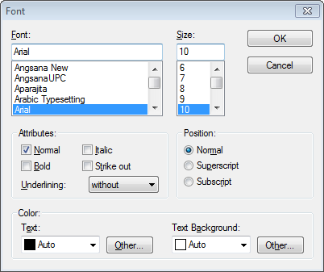
The Attributes section is where you can change the style to bold, italics or use strike out and add underlining. Simply click in the check box to the left of the attribute you wish to use – you can use any combination! If you wish to underline your text, click on the dropdown arrow and choose from 'without', 'single', 'double' or 'words only' where the spaces and characters (such as commas) between the words are not underlined.
The Position section allows you to have superscript or subscript simply by clicking on the desired radio button. There’s no need to change the size of your font to a smaller one when using this feature, Ableword will reduce the font automatically!
The Colour section allows you to change the colour of your text by clicking the dropdown arrow and selecting which colour you want. If the colour you desire isn’t showing in the list, click on the ‘Other’ button and then you can custom make a colour that suits you. This section also allows you to highlight text by changing the background colour, for example, to red to make that text stand out more. Again, you do this by clicking the dropdown arrow and selecting which colour you want, or using the ‘Other’ button to custom make a colour that suits you.

Document information
When you click on this icon it will bring up a window showing some statistics on your document – ideal if you need to meet a word target or document size! This shows the word count, number of pages, number of characters, paragraphs and lines. When you’ve finished reading your statistics simply click OK and the window will close.

Find
This feature allows you to find a specific string of characters such a part of a word, a whole word or a few words that show together. Simply click the icon, type in the ‘Find What’ box the characters you’re looking for and then click on ‘Find Next’. Ableword will default to match the case you have typed, and to search from where your cursor is down through the document. You can simply click and remove the tick from the Match Case box or click the radio button to change the direction. If Ableword cannot find the characters you are looking for it will simply say the end of the document has been reached. If it can find what you’re looking for it will highlight that text and show you where it is. When you have finished using this feature simply click the ‘cancel’ button and the search window will close.

Spelling
By clicking this button Ableword will check the spelling in your document against its default dictionary (US English, with more dictionaries coming soon) and will highlight any words not showing in the dictionary for you to accept or correct. At this point you can add words to the dictionary, for example names, simply by clicking the Add to Dictionary button. You can also ignore errors, either once (and then Ableword will continue to show you this error if it appears later in the document) or all occasions in this document. If Ableword can, it will make suggestions for correcting the error. You can then ask Ableword to change just this occurrence of the error (by selecting the correct word and then clicking on the Change button) or all the occurrences (again, by selecting the correct word but then click on the Change All button) If Ableword can’t find a suitable suggestion, you need to close the Spelling window and correct the word yourself.
You can change the dictionary Ableword is using by clicking the dropdown arrow next to the Suggestions Dictionary showing.
Remember, a spelling checker will only flag errors where you have typed a word that it doesn’t think exists. It’s always worth proof-reading your document to make sure you haven’t any other errors!

Show/Hide Formatting Characters
By clicking this icon Ableword will show you little symbols to represent things such as spaces, returns and page breaks. This can be handy to use, for example when you want to see if you inserted a page break or if Ableword is automatically breaking the page at that point. Click the icon again to hide these symbols.

Working with Images:

Insert Image
When you click this icon Ableword will open a search box so you can find any image you wish to insert. You can change the file type you are looking for by clicking in the dropdown box on in the bottom right hand side. Ableword defaults to Windows Bitmap (.bmp) but will also support:
Tagged Image Format (.tif)
Windows Metafile (.wmf)
Portable Network Graphic (.png)
JPEG File Interchange Format (.jpg)
Graphics Interchange Format (.gif)
Windows Enhanced Metafile (.emf)
When you have found your file, click on OK and Ableword will insert your picture into your document. If you wish to change the size of the picture in your document simply click on the picture itself. In each corner, and halfway down each side, little boxes will appear. Click into one of the boxes and hold your mouse button down, then drag that box until the picture is the size you want. When you have finished, simply let go of your mouse button and then click somewhere away from the picture.

Using Text Frames:

Insert Text Frame
To use this feature, make sure your cursor is at the end of a line or at the start of a fresh line. Then click the icon and Ableword will insert an empty box into your document where your cursor currently is.
Click into this box to fill it with text, or even a picture. If you want to change the size of your text box, hover over the edge of it with your mouse. Your cursor will then change shape to a four headed arrow> then click on the edge of your text box. In each corner, and halfway down each side, little boxes will appear. Click into one of the boxes and hold your mouse button down then drag until the text box is the size you want. When you have finished, simply let go of your mouse button and then click somewhere away from the box. You can also use these little markers to move the text box around your document – it can go anywhere!
Anything you’ve inserted into the text box will move too. If you insert a picture into a text box, you might need to change the size of the picture to make it fit nicely. To do this simply click on the picture itself. In each corner, and halfway down each side, little boxes will appear. Click into one of the boxes and hold your mouse button down, then drag that box until the picture is the size you want. When you have finished, simply let go of your mouse button and then click somewhere away from the picture.

Using Tables:

Insert Table
Clicking this icon brings up a new small window. If you want to insert a table, make sure your cursor is where you want the table to appear before clicking on this icon. This makes things easier later on (although you can easily use the Cut and Paste icons to move the table if you wish). Once you’ve clicked on this icon you first need to decide on your table size by selecting the number of columns and the number of rows. Ableword defaults to 5 columns, 4 rows and to change these simply click on the arrows to the right of the numbers. Alternately, click into the boxes showing the number of columns/rows and simply type the number you require.
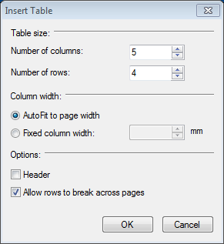
Ableword defaults to automatically sizing your table to fit the page width, regardless of the number of columns. If you increase the number of columns, each column will be smaller. If you decrease the number of columns, each column will become larger. You can also tell Ableword to fix the column width by clicking the radio button for ‘Fixed Column Width’. Once you have clicked here Ableword will activate the box where you can specify how wide you want each column to be. Simply use the up and down arrows or alternately click into the box showing the column width number and type in the value you require. However, once you have inserted the table, you can change the column sizes. Hover your cursor over the column edge you wish to move and your cursor will change shape to a double headed ‘move’ cursor. At this point click and hold your mouse button then drag the column edge to where you want it to be. This is very handy for resizing columns after you have entered your table contents.
By clicking into the Header box, Ableword will repeat the top row of your table if it’s so large it goes onto more than one page. By putting the tick in here, when your table goes onto the next page, you will see a new row appear with your header text already completed.
Ableword allows you to make sure your table is not split by a natural page break. Simply click into the box ‘Allow rows to break across pages’ and remove the tick.
Click on OK when you are finished, the window will close and your table will be inserted where your cursor was. Now simply click into the cell you want to start typing in and off you go. Within each cell, if you press Enter you will stay within that cell, but if you click Tab you will move to the next cell. You can format the contents of your table in the same way as the rest of your document. You can even insert another table into one of the cells of your table!

Font Formatting Toolbar
To make your work a little easier, Ableword automatically shows a quick formatting toolbar. This includes some commonly used formatting features.
First you can choose your desired font & font size.
By clicking on:
B you can change the style to bold
I changes your style to italics
U adds single underlining
You can use any combination simply by clicking on the letter representing the style, and if you change your mind simply click on that style again to turn it off. If you have already typed the text you wish to format, highlight all the text you wish to format and then click on the style buttons you wish to use.

Ableword defaults to using ‘left justify’ – this user manual is all set to Left Align. It means you have a smooth edge on the left, a ragged edge to the right and all spaces between words are the same size.
The next choice is Right Align and this is the opposite of Left Align in that you have a smooth edge on the right of your text, a ragged edge to the left and all the spaces between words are the same size. Like this paragraph. It’s ideal for addresses at the top of letters.
The next choice is Centre. This is where Ableword aligns text in the centre of the page, giving a ragged edge to both the left and right. It’s a good look for invitations or poems and can really enhance your display. This paragraph has been Centred.
Finally there is the choice to Justify. This is where Ableword spreads your typing out, regardless of how long or short your words are, to give smooth edges both left and right sides. This looks very neat, at a glance, but can give you some odd results if you have some very long words within your text. If you use Justify it ’s a very good idea to scan through your document to check for odd looking text where perhaps you could restructure your sentence for a smoother look. This paragraph is Justified and you’ll notice that the final line does not get spread to fit both left and right sides.

Bullets
Clicking this icon will start each paragraph with a ‘bullet’. Make sure you’re on the line you want the bullets to start, then click this button. Ableword will start each new paragraph with a bullet that sits on your left hand margin with the text slightly indented:
This is how bulleted paragraphs look:
- Bullet 1
- Bullet 2
- Bullet 3
When your paragraph is more than one line long Ableword aligns the block of text nicely to the left, but slightly indented to un-bulleted text. When you press enter you start a new paragraph. If you want to break up your text without starting a newly bulleted paragraph then simply press and hold your Shift key whilst pressing Enter. Yyou can Shift+Enter as many times as you like for presentation purposes.
When you wish to stop putting bullets at the start of your text, press Enter to start a new line and then click on the Bullets icon again to turn it off. To use more advanced features of Bulleting paragraphs, click on the Format Menu and select Bullets and Numbering.

Numbering
Clicking this icon will start numbering your paragraphs. Make sure you’re on the line you want the numbering to start, then click this button. Ableword will start the numbering at 1, and increase with each new paragraph. The paragraph number sits on your left hand margin with the text slightly indented:
- Here I’m showing you how the numbering will look. When your paragraph is more than one line long you can see Ableword aligns the block of text nicely to the left, but slightly indented to un-numbered text.
- When you press Enter, you start a new paragraph. If you want to break up your text without starting a newly numbered paragraph then simply press and hold your Shift key whilst pressing enter
The result looks like this, although you can Shift+Enter as many times as you like for presentation purposes.
- Above I have used Shift+Enter, then Enter, to space out the paragraphs.
When you wish to stop numbering your text, press Enter to start a new line and then click on the Numbering icon again to turn it off. If you want to number more text further on in your document Ableword will default to start numbering where you left off. To use more advanced features of Numbering paragraphs, click on the Format Menu and select Bullets and Numbering.

Tab Stops
Ableword has already inserted tab-stops every 2cm, set to align your text to the right. To use these existing tabs, simply press your tab button until you reach the stop you want to use.
It’s easy to add new tab stops from the shortcut menu. Make sure your cursor is on the line that you wish to use then click on the tab stop button to pick the type of tab stop you wish to use. You have the choice of:
Align text to the right
Align text to the left
Centre text at this point
Decimal – this centres numbers from the decimal point
Align to the right margin (the right-most tab)
When you’ve chosen which tab stop you want to use, click on the ruler where you want the tab stop to be:

To use the tab stop, simply click on your tab stop button to get there and start typing. If you want to remove the existing tab stops, you need to go to the Format Menu and select TABS.
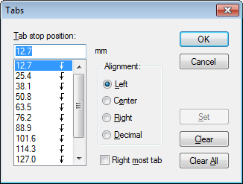
This will bring up a dialogue box where you can see Ableword’s default tab stops in the list. Click on the tab stop you wish to remove then click on Clear. If you want to remove all the tab stops, simply click on Clear All. You can also add new tab stops or amend the existing ones from this menu.

To amend an existing tab stop, click on the item in the list that you wish to change then you can amend the alignment. When you have finished amending, click on OK and the changes will show in your ruler.

To add a new tab stop, click into the top box and type where you want the tab stop to be, eg 150 = 150mm to the right of the left-hand margin. Then select the radio button for how you want this tab stop to be aligned. When you’ve finished, click on OK and your new tabs will show in your ruler.

Using AbleWord as a PDF Editor

Editing PDFs
One of the best features of AbleWord is the ability to load PDF's and edit them as easily as any other documents.
Simply open the pdf file you want to edit and you’re set! Ableword will open this pdf ready for editing, When you’re done, simply save in whatever format you wish – Word, pdf or any of the other supported file types.
Click on the File Open button on the toolbar
Now you can make changes to the PDF easily
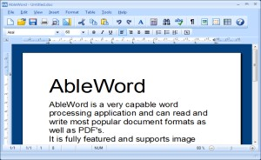
When you are done press the Save button or choose 'Save As' from the File menu if you want to save using a different filename or type.

Notes
It should be noted that PDFs were original developed for pre-press use and are actually a page layout document which supports many more features than are available in a Word Processor. For example precise text alignment and rotation. AbleWord will try and match the original PDF as closely as possible which often means inserting text inside text frames and the use of next-best font available on your system. So be aware that the end result may look slightly different then the original. If the original document was created using Word® then it should import very well.
AbleWord will import all PDF objects text, fonts, shapes, lines and images so if you are importing a "Scanned PDF" this may only contain images and no text. To be able to edit a scanned pdf document you will need to use OCR software which is out of the scope of AbleWord features. We recommend FreeOCR for a free, easy solution to OCR and edit a scanned PDF. After OCR you can simply copy and paste the text into AbleWord for reformatting.
PDF files have become increasing popular over the years (since 1992 actually) and are used for general document exchange on the internet and although they are still used for pre-press, most PDFs are created from general office documents using widely available "PDF Printers". For these documents AbleWord should be able to create a near perfect copy which will make editing easier.

Page Setup

Margins and Paper
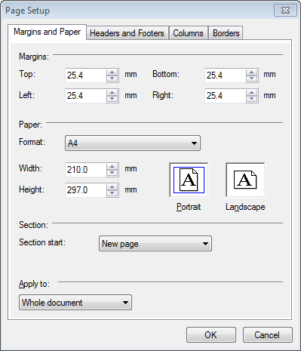
Margins
Here you can change the width of all your margins. They will default to 25.4mm all round (one inch) but are easily changed by using the up and down arrows to the left of each selection. Alternatively you can click into the margin boxes and overtype the number shown. The minimum margin size depends upon your printer.
Paper
The default is A4 Portrait (210mm wide and 297 high) but this is easily changed. Use the dropdown menu ‘Format’ to change your paper size. You have an amazing 134 standard sizes to choose from, plus the option to set a custom size. If you wish to set a custom size, select that option from the list and then overtype the Width and Height, or use the up/down arrows until your desired size is displayed. It’s also very easy to change from Portrait to Landscape, and vice versa, simply by clicking in either the Landscape or Portrait box. If you have already created a custom size for your pages, changing the paper orientation will automatically swap the width and height settings without losing your customisation.
Section
Set to ‘new page’ as the default and can be changed to ‘continuous’. If you insert section breaks in your document, using this feature will default to automatically start a new page. Changing the default to ‘continuous’ simply means a new section will start without a page break.
Apply to
This defaults to ‘whole document’ and can be changed to ‘section’ to allow different margins, paper and orientation for a segment within your document where you have used the ‘section’ function.

Headers and Footers
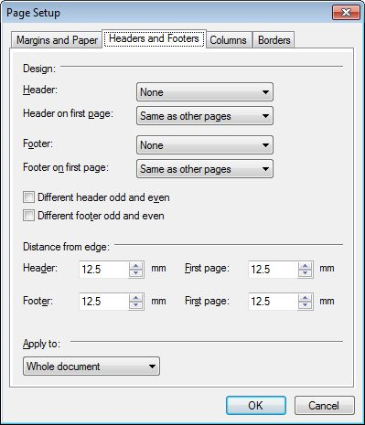
Design
This section allows a great deal of flexibility for your headers and footers. For both the Header and Footer individually you can select:
- None (no header or footer)
- All Sections Equal (headers are the same on each page, footers are the same on each page)
- All Sections Different (each header/footer can be completely different)
You can also select these options for the Header and Footer on the first page only. Ableword allows you to select different headers and footers for odd and even pages also by clicking into the check box for these options.
Distance from edge – these values determine how far the header and footer are inset from the left hand edge of your page. Again, you can select different values for the first page of your document. To change these values either click into the white box and overtype the existing values, or use the up and down arrows. The default settings are 12.7mm (half an inch) for header, footer and first page.
Apply To – this defaults to ‘whole document’ and can be changed to ‘section’ to allow for different header and footer settings for each segment within your document where you have used the ‘section’ function.

Columns
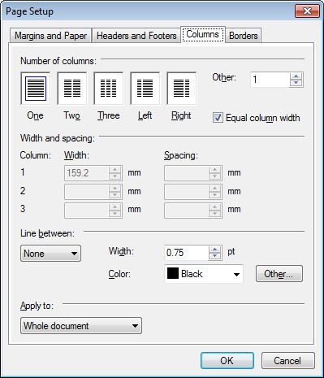
This tab allows you to easily produce a newspaper/newsletter-style layout.
Number of Columns
The default number of columns is 1, but can simply be changed to however many columns you desire. There are buttons to select 2 or 3 equal columns and 2 columns with one thinner, one thicker column. However, you can also use the ‘Other’ feature and increase the number of columns to however many you want. There’s a check-box to make all columns equal size so if you want each column to have a different width, simply click on the tick to remove it.
Width and Spacing
Here you can change the sizes of each of your columns, when you have more than one column. Ableword will automatically complete these values when you select more than 1 column, including how much space to show between columns, but it’s a simple matter of using the up/down arrows (or clicking into the boxes and overtyping the values) to change your column widths and the spacing between each column.
Line Between
The default setting is none. If you have more than one column in your document, you may wish to separate each column by a line. If you do, change this setting from ‘none’ to ‘single’. You can also change the thickness of this line and the colour. Ableword allows you to even customise the colour of this line!
Apply to
This defaults to ‘whole document’ and can be changed to ‘section’ to allow for different column settings for each segment within your document where you have used the ‘section’ function.

Borders
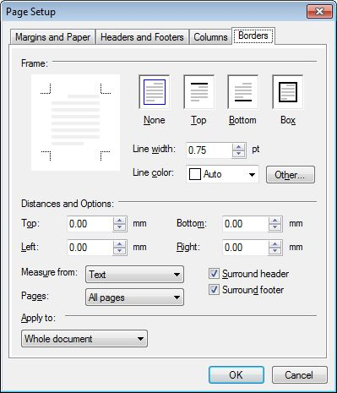
This tab allows you to insert outline boxes around your text. This is another useful feature to help you produce professional newspapers and newsletters but also can be used to outline text for notices, invitations and the like.
Frame
The default is no frame but you can select to have a line at the top or bottom of your document, or a box simply by clicking into the relevant box. The line is a fine 0.75pt but this can be increased or decreased by using the up/down arrows to the right of the Line Width box, or by overtyping the number showing. You might also want to choose a different colour for these lines by using the dropdown list for Line colour or clicking on the ‘other’ button to customise your colour choice.
Distances and Options
Here you can specify how far away you want the border to be. The Measure From feature allows you to say whether to measure the distance from the edge of the document (so from the outside inwards) or from the text (so from the text outwards). You can also choose to put a border around the header or footer – the default is no border around these. Ableword gives you the choice of which pages to apply these settings – all pages, just the first page or all pages except the first page.
Apply to
This defaults to ‘whole document’ and can be changed to ‘section’ to allow for different border settings for each segment within your document where you have used the ‘section’ function.

